EFFECT OF EMPAGLIFLOZINE ALONE AND IN COMBINATION WITH METFORMIN ON CONTROLLING GLYCEMIC STATUS AND LIVER FUNCTIONS IN NA-STZ DIABETIC RATS

Abstract:
Background: Non-alcoholic steatohepatitis is acondition of which diabetic fatty liver accounts for a large proportion. Metformin (met) is one of the most commonly used drugs to treat Diabetes Mellitus (DM) type II. Empagliflozin (Empa) is a sodium -glucose co-transporter 2 inhibitors , which has recently been shown to improve the prognosis in high-risk cardiovascular patients. Aim of the study: this work aimed at exploring the possible prophylactic effect of empa alone and in combination with met on NASH induced experimentally by high fat diet in rats with DM type II. Material and methods: 36 Rats were divided into 5 groups after experimental inductuion of DM type II : Control normal group , Untreated NASH diabetic group (received a high fat diet for 12 weeks), Met pre-treated NASH diabetic group (treated with met 100 mg/kg/day orally for 12 weeks) , empa pre-treated NASH diabetic group (treated with empa 10 mg/kg/day orally for 12 weeks) and met and empa pre-treated diabetic group(treated with met100 mg/kg/day and empa 10 mg/kg/day orally for 12 weeks). Results: Met and empa produced reduction of liver enzymes , total cholesterol, triglycerides and LDL-c , fasting blood glucose , insulin level and insulin resistance index and significant elevation of HDL-c and serum adiponectin These results were supported by marked improvement of liver histopathology compared to non-treated NASH diabetic group, with the best results obtained by administration of met along with empa . Conclusion:It was found that met and /or empa affords hepatoprotective effects.

Key words:Non-alcoholic steatohepatitis, high fat diet , Metformin and Empagliflozin.

Introduction
NASH is a common chronic condition of which diabetic fatty liver accounts for a large proportion, with 50 to 75% of the subjects demonstrating fat in the liver on Ultrasound. As a result of epidemic increase in obesity, hyperlipidemia and diabetic patients ,the prevalence of NASH in the general population is increasing. NASH encompasses both simple steatosis and non-alcoholic setatohepatitis, which may ultimately lead to liver cirrhosis . NASH can lead to liver related death in 12-25%. It can develop into sub- acute liver failure and hepato cellular carcinoma .¹The progression of the disease makes insulin secretion unable to maintain glucose homeostasis, producing hyperglycaemia. Patients with DM type II are mostly characterized by being obese or having a higher body fat percentage, distributed predominantly in the abdominal region. In this condition, adipose tissue promotes insulin resistance (IR )through various inflammatory mechanisms, including increased free fatty acid (FFA) release and adipokine deregulation. ² Metformin is a kind of general insulin sensitizer.³ Although its molecular mechanisms of action are complex and not completely understood, metformin has been shown to act via both adenosine monophosphate-activated protein kinase (AMPK)-dependent and AMPK-independent mechanisms.⁴
Empagliflozin is one of SGLT2 inhibitors which are novel class of anti-diabetic drugs that improve hyperglycemia by inhibiting urinary glucose reabsorption from the kidney. ⁵In addition to a glucose-lowering effect, SGLT2 inhibitors exert several cardio-renal and metabolic benefits, including weight loss.⁶
This work aimed at exploring the possible prophylactic effect of empagliflozin alone and in combination with metformin on NASH induced experimentally by high fat diet in rats with diabetes mellitus type II.
MATERIALS AND METHODS
Animals: 36 Adult male albino rats (brought from Vacsera-Cairo) weighing between 150-180 g (at the beginning of the study), were used for in-vivo experiments. They have acclimatized for one week and were caged in fully ventilated room (at temperature ranging from 25-30ºc). Food and water were provided ad libitum.
Type of study: prospective
Duration: 10/2/2021 to 20/6/2021
Place: pharmacology department-benha faculty of medicine
Ethical considerations:
Experimental rats were placed under complete healthy conditions all over the experiment in the form of:
-Clean environment.
-Good ventilation.
-Good nutrition.
-Number of rats in each cage was eight.
-The rats were under the care of a professional technician and a qualified researcher. The study was approved by the ethical committee of Faculty of medicine, Benha University, which adopt the guidelines for ethical conduct in the care and use of animals provided by American Association of Psychologists.
Drugs and chemicals:
Empagliflozine powder (Pharma biotechnology, India). Cholesterol powder : (Sigma chemical company). Metformin powder (Pharma biotechnology, India).
Metformin and empagliflozin were dissolved in distilled water.
Induction of NASH on top of NA-STZ DM type II:
DM type II was induced in rats by a single IP injection of streptozotocin (STZ )(65Mg /kg BW), 15minutes after IP administration of nicotinamide (NA) (110 mg/kg BW). STZ was dissolved in citrate buffer (0.1 M, pH 4.5) and NA was dissolved in normal saline. ^{7,8}
NASH was induced by high fat diet formed of a laboratory chow diet in addition to 10% animal fat, 2% cholesterol, and 5% corn oil for 12 weeks.⁹
* Animal groups:-
36 adult male albino rats were divided into five groups: Group I (Control normal group): received a standard chow diet and tap water with no medication, Group II (Untreated NASH diabetic group): received a high fat diet for 12 weeks with no medication after induction of NA-STZ DM type II⁹ , Group III (Metformin pre-treated NASH diabetic group): received a high fat diet with oral administration of metformin at a dose of (100 mg/kg/day) for 12 weeks after induction of NA-STZ DM type II ^{9,10} and Group IV (Empagliflozin pre-treated NASH diabetic group): received a high fat diet with oral administration of empagliflozin at a dose of (10 mg/kg/day) for 12 weeks after induction of NA-STZ DM type II. ^{9,11} and Group V (Metformin and empagliflozin pre-treated NASH diabetic group): received a high fat diet with oral administration of metformin at a dose of (100 mg/kg/day) and empagliflozin at a dose of (10 mg/kg/day) for 12 weeks after induction of NA-STZ DM type II. ^{9,10,11}
Sample collection
At the end of the 12th week ,rats were overnight fasted for 8 hours,blood samples were taken from rats tails for assessment of fasting blood sugar ,then fasting was compeleted for 12 hours. rats were weighed for calculation of LWI (liver weight index), rats were anesthetized with urethane a dose of 0.6 ml/100 gm BWT of 25% fresh prepared solution¹¹ the blood sample was taken from the heart by syringe. Samples for biochemical analysis of liver enzymes, lipid profile and insulin levels were incubated at 37ºc until blood clotted and then centrifuged at 3000 revolution per minute (rpm) for 15 min for separation of serum and stored at – 20º C.¹²
1-Determination of liver function tests: were performed on samples by colorimetric methods (AST, ALT), by using ALT and AST kit (Human , Egypt),according to the method of Reitman and Frankel. ¹³
2-Determination of serum lipid profile: Serum levels of total cholesterol (TC), triglyceride (TG) and high- density lipoprotein-cholesterol (HDL-C) were determined using colorimetric enzymatic kits (Bio Diagnostic, Dokki, Egypt) according to the manufacturer‟s instructions.¹⁴,^{15,16} Low-density lipoprotein cholesterol (LDL-C) was calculated using the Friedewald formula [LDL- cholesterol= Total Cholesterol- (HDL-cholesterol+ TG/5) (mg/dl)]. ¹⁷
3-Liver mass index (LMI):
The liver was immediately removed and weighed after rinsing with ice cold saline . The liver weight index (%) was calculated as liver weight/body weight × 100.
4-Measurement of fasting blood glucose:
Fasting blood glucose was measured on a Beckman Glucose Analyzer II (Beckman, Fullerton, CA). ¹⁸
5-Measurement of fasting insulin level: by rat insulin ELISA kit (SunLong Biotech Co., LTD) .¹⁹
6-Insulin resistance by HOMA-IR index: Insulin resistance was measured using the homeostasis model assessment (HOMA-IR) defined by the following formula: ²⁰
HOMA-IR=Fasting glucose level (mg/dl) x Fasting insulin level (μIU/mL) /405.
7- Measurement of serum adiponectin level: using Adiponectin rat ELISA kits (Biovendor,Germany),This ELISA kit uses Sandwich ELISA as the method. ²¹
Histopathology of the liver:
After functional studies were completed, the liver of rats were put into a buffered 4% formaline fixation solution and processed with paraffin wax for histopathological examination. Sections (5μm) were stained with hematoxylin and eosin. ²²
Statistical analysis: In the statistical comparison between the different groups, the significance of difference was tested using ANOVA test (F value):-Used to compare mean of more than two groups of quantitative data using multiple comparison post hoc test (LSD). P value <0.05 was considered statistically significant while >0.05 statistically insignificant P value <0.01 was considered highly significant.

RESULTS
Induction of NASH by high fat diet in diabetic rats resulted in significant elevation in liver enzymes (AST and ALT) (figure1,2), TC, TG, LDL-C (table2), fasting glucose and insulin levels and insulin sensitivity (table1) with significant reduction of HDL-C (table 2) and serum adiponectin level (figure4) in untreated NASH group when compared to control group.
Treatment with metformin and /or empagliflozin resulted in significant reduction of liver enzymes (AST and ALT) (figure1,2), TC, TG, LDL-C(table2), fasting glucose and insulin levels, with improvement of insulin sensitivity observed by lowering of HOMA-IR index(table1). The serum HDL-C (table 2) and adiponectin levels (figure4) were significantly elevated in treated groups when compared to untreated NASH group, with the best results in combination group.
Microscopic examination of liver sections of rats of control group displayed normal liver architecture (figure5). Rats of untreated-NASH diabetic group showed severe steatosis, hepatocyte ballooning and degeneration with multiple foci of inflammatory cell infiltration (figure 6). Whereas, hepatocyte ballooning and degeneration and the infiltration of inflammatory cells were markedly ameliorated in metformin pre-treated NASH diabetic group and empagliflozin pre-treated NASH diabetic group (figure 7,8). However combination therapy exhibited better improvement of liver architecture (figure 9).

 | Parameters mean ± SD
HOMA IR | Plasma insulin( IU/L) | FBG(mg/dl) | Groups
1.35  ±0.105 | 6.95  ±0.10 | 84.93  ±5.71 | Group I: Normal control  Group
17.33  ±0.82 ª | 25.83  ±2.14 ª | 198.5  ±9.89 ª | Group II: NASH diabetic non treated group group
13.17  ±0.75 ^{ab} | 17.17  ±1.17 ^{ab} | 177.17  ±9.85 ^{ab} | Group III: Met pre- treated NASH diabetic group
9.0  ±2.37 ^{abc} | 13.83  ±0.75 ^{abc} | 155.17  ±8.38 ^{abc} | Group IV: Emp pre-treated NASH diabetic group
3.88  ±0.23 ^{abcd} | 10.33  ±0.52 ^{abcd} | 113.17  ±2.48^{abcd} | Group V: Met +Emp pre-treated NASH diabetic group

Table ( 1 ): Effect of pre- treatment with metformin (100mg/kg/day orally) and /or empaglifozine (10 mg/kg/day orally) for 12 weeks in experimental induction NASH on top of NA-STZ DM type II in adult male albino rats on FBG ,fasting plasma insulin level and HOMA IR.

Data are presented as Mean ± SD
a: Significant difference versus control group<0.05.

b: Significant difference versus NASH diabetic non treated group at p<0.05.
c: Significant difference versus Met. treated NASH diabetic group at p<0.05.
d: Significant difference versus Empa .treated NASH diabetic group at p<0.05.

 | Parameters mean ± SD
VLDL(mg/dl) | LDL(mg/dl) | HDL(mg/dl) | CH(mg/dl) | Groups
26.00  ±4.47 | 74.67  ±3.67 | 95.83  ±4.96 | 33.67  ±1.03 | Group I: Normal control  Group
90.00  ±4.47 ª | 112.33  ±3.88 ª | 76.50  ±3.45 ª | 76.17  ±2.14 ª | Group II: NASH diabetic non treated group group
64.17  ±2.64 ^{ab} | 95.83  ±1.84 ^{ab} | 95.33  ±4.18 ^{ab} | 59.50  ±1.22 ^{ab} | Group III: Met pre- treated NASH diabetic group
52.83  ±3.87 ^{abc} | 87.67  ±1.51 ^{abc} | 107.17  ±3.66 ^{abc} | 49.83  ±1.17 ^{abc} | Group IV: Emp pre-treated NASH diabetic group
43.33  ±1.03 ^{abcd} | 80.67  ±0.82 ^{abcd} | 130.17  ±3.76 ^{abcd} | 41.83  ±1.60^{abcd} | Group V: Met +Emp pre-treated NASH diabetic group

Table (2): Effect of pre -treatment with metformin (100mg/kg/day orally) and /or empaglifozine (10 mg/kg/day orally) for 12 weeks in experimental induction NASH on top of NA-STZ DM type II in adult male albino rats on lipid profile

Data are presented as Mean ± SD
a: Significant difference versus control group<0.05.
b: Significant difference versus NASH diabetic non treated group at p<0.05.
c: Significant difference versus Met. treated NASH diabetic group at p<0.05.
d: Significant difference versus Empa .treated NASH diabetic group at p<0.05.

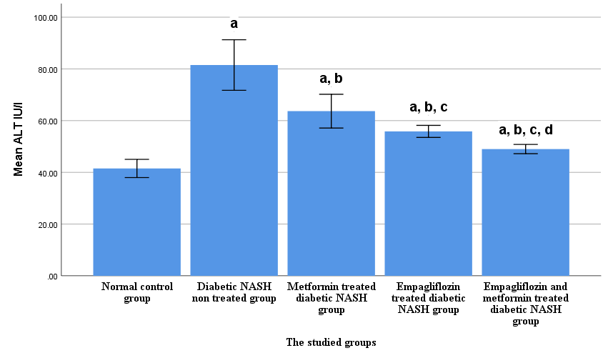Figure ( 1 ): Effect of pre- treatment with metformin (100mg/kg/day orally) and /or empaglifozine (10 mg/kg/day orally) for 12 weeks in experimental induction NASH on top of NA-STZ DM type II in adult male albino rats on ALT:

N.B

a: Significant difference versus control group at p<0.05.
b: Significant difference versus NASH diabetic non treated group at p<0.05.
c: Significant difference versus Met. treated NASH diabetic group at p<0.05.
d: Significant difference versus Empa .treated NASH diabetic group at p<0.05.

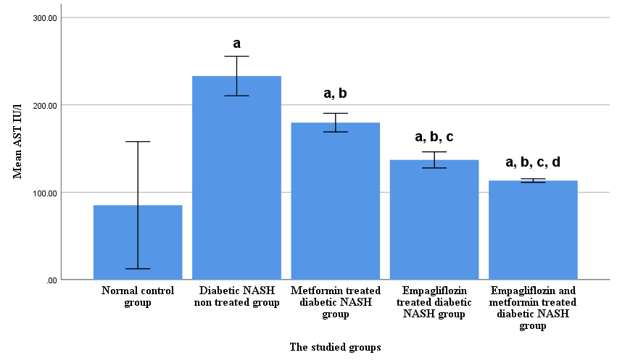Figure ( 2 ): Effect of pre- treatment with metformin (100mg/kg/day orally) and /or empaglifozine (10 mg/kg/day orally) for 12 weeks in experimental induction NASH on top of NA-STZ DM type II in adult male albino rats on AST.

N.B

a: Significant difference versus control group at p<0.05.
b: Significant difference versus NASH diabetic non treated group at p<0.05.
c: Significant difference versus Met. treated NASH diabetic group at p<0.05.
d: Significant difference versus Empa .treated NASH diabetic group at p<0.05.

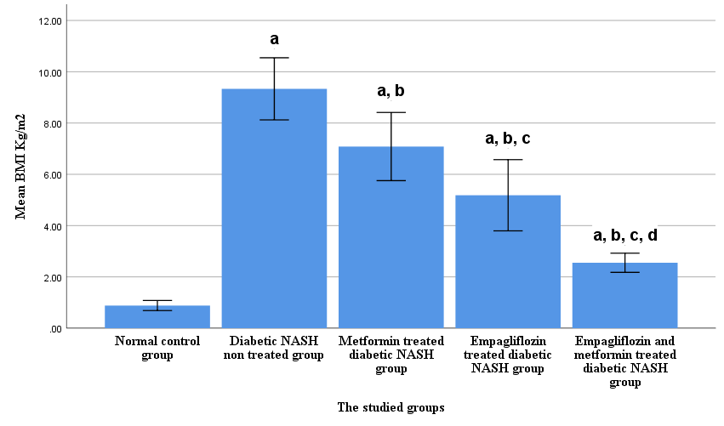
Mean liver weight index index

Figure (3): Effect of pre -treatment with metformin (100mg/kg/day orally) and /or empaglifozine (10 mg/kg/day orally) for 12 weeks in experimental induction NASH on top of NA-STZ DM type II in adult male albino rats on Liver weight index.

NB

a: Significant difference versus control group at p<0.05.
b: Significant difference versus NASH diabetic non treated group at p<0.05.
c: Significant difference versus Met. treated NASH diabetic group at p<0.05.
d: Significant difference versus Empa .treated NASH diabetic group at p<0.05.

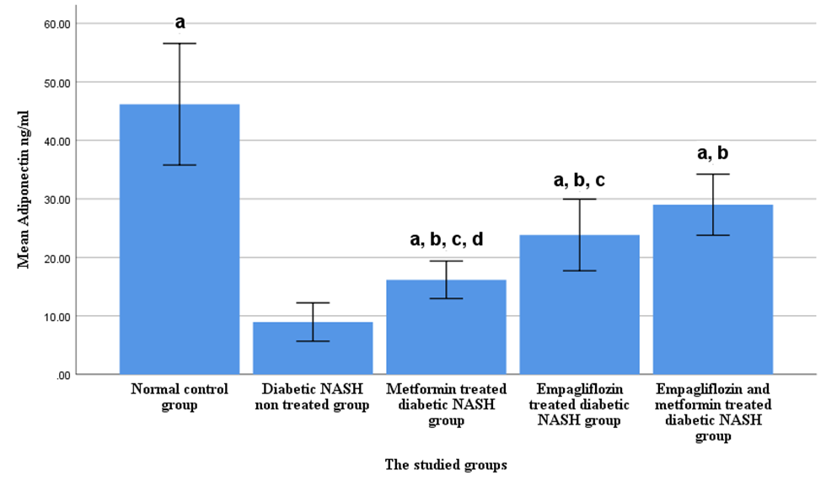
Figure (4): Effect of pre- treatment with metformin (100mg/kg/day orally) and /or empaglifozine (10 mg/kg/day orally) for 12 weeks in experimental induction NASH on top of NA-STZ DM type II in adult male albino rats on adiponectin.

N.B

a: Significant difference versus control group at p<0.05.
b: Significant difference versus NASH diabetic non treated group at p<0.05.
c: Significant difference versus Met. treated NASH diabetic group at p<0.05.
d: Significant difference versus Empa .treated NASH diabetic group at p<0.05.

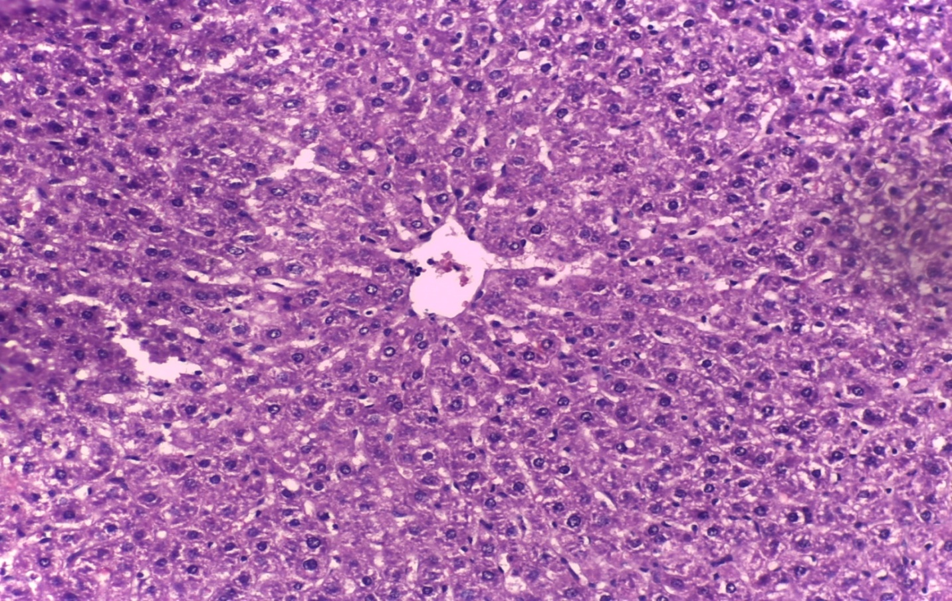
B
A
Figure(5): A photomicrograph of a cut section in the liver of normal control rat showing normal liver architecture composed of hexagonadal or pentagonadal lobules with (a)central veins and peripheral hepatic triads or tetrads embedded in connective tissue.(B) Hepatocytes are arranged in trabecules running radiantly from the central vein and are separated by sinusoids (H x & E x 20).

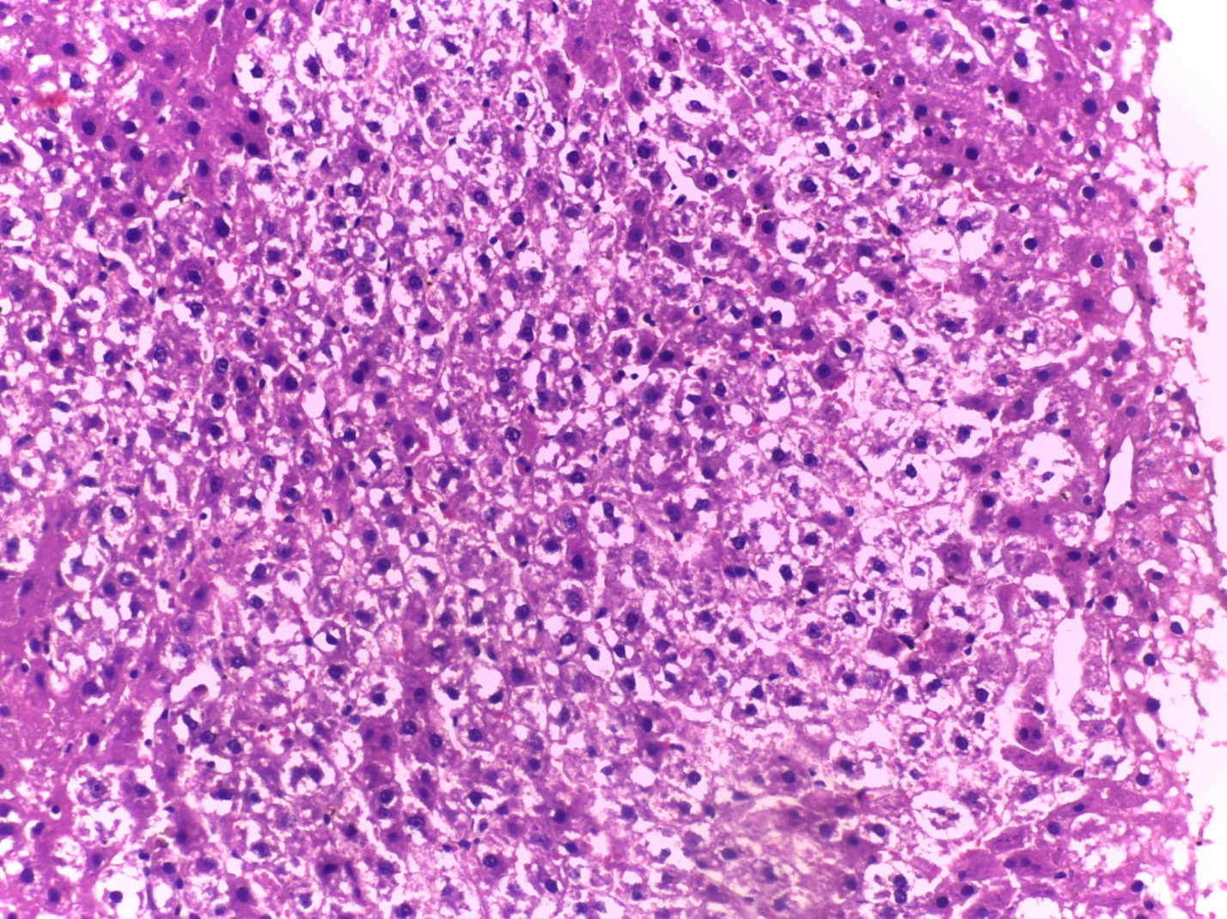
D
C
B\B
A

Figure (6): A photomicrograph of a longitudinal section in the liver of NASHdiabetic non treated rats showing preserved liver architecture, (A)hepatocytes show marked steatosis (B) hepatocytes show marked hydropic changes, (C) some necro- inflammmatory foci in hepatic nodule & (D) portal tract inflammation(H x & E x 20).

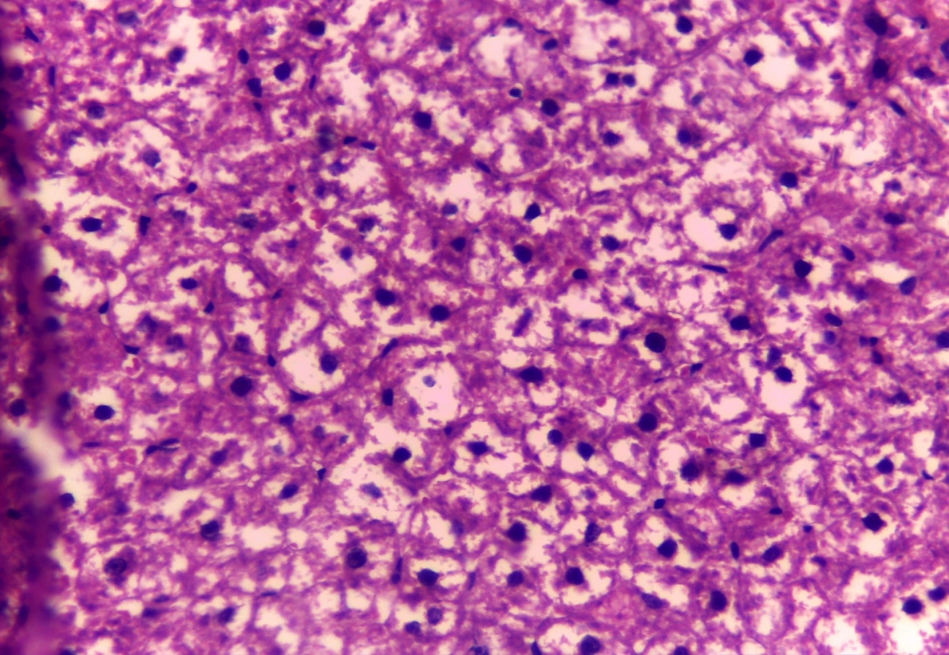
C
B
A

Figure (7): A photomicrograph of a longitudinal section in the liver of metformin treated NASHdiabetic rats showing preserved liver architecture, (A)hepatocytes show steatosis
(B) hepatocytes show hydropic changes, (C) some inflammmatory foci in hepatic nodule of lesser degree than diabetic NASH non treated rats (H x & E x 20).

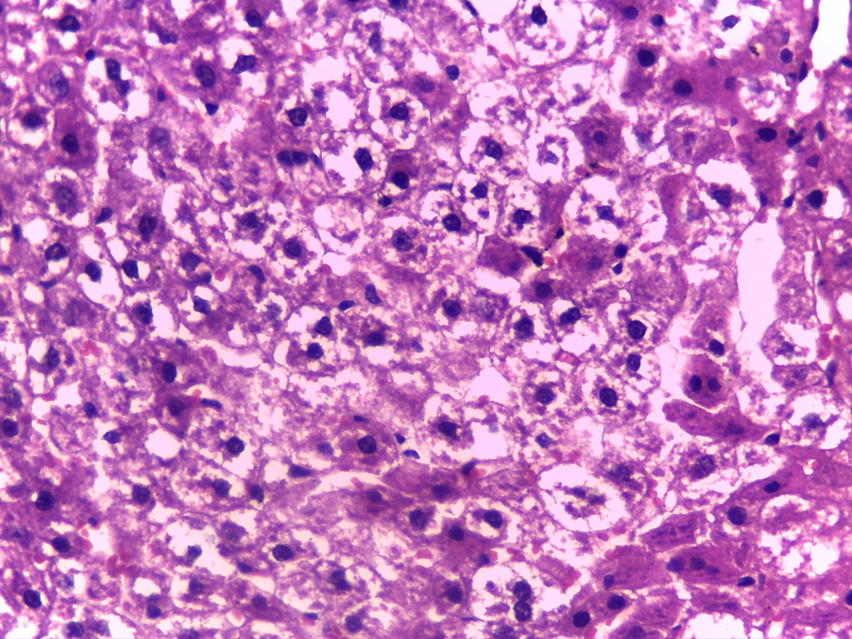
C
B
A

Figure (8): A photomicrograph of a longitudinal section in the liver of empagliflozin treated NASHdiabetic rats showing preserved liver architecture, (A) hepatocytes show steatosis (B) hepatocytes show hydropic changes, (C) some inflammmatory foci in hepatic nodule of lesser degree than diabetic NASH non treated rats (H x & E x 20).

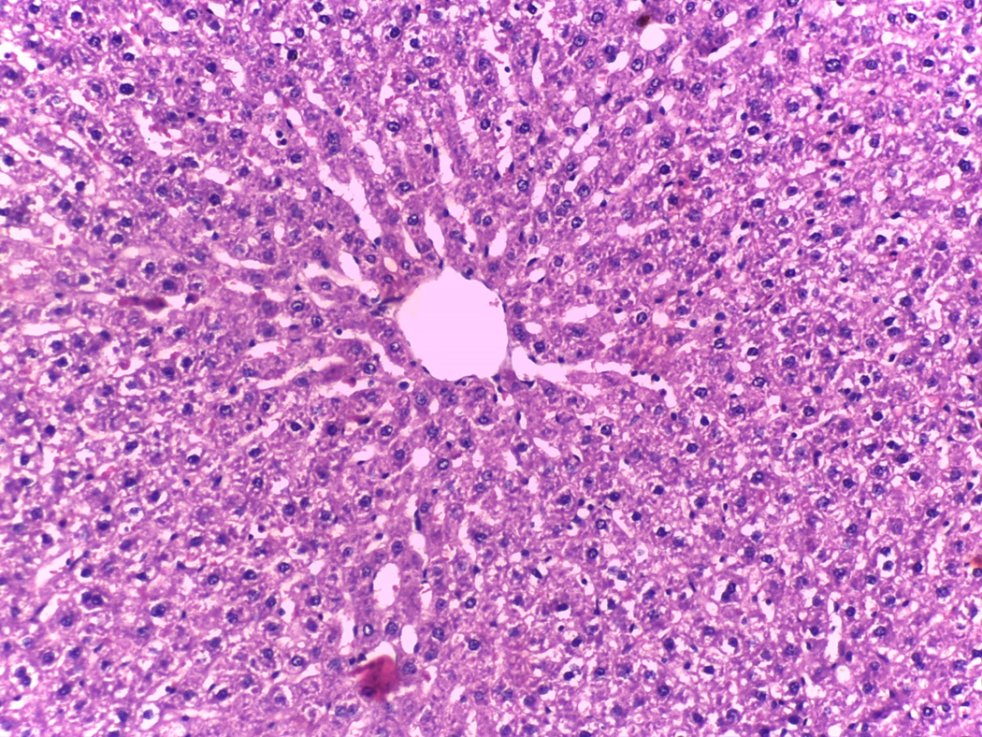
B
A
Figure (9): A photomicrograph of a longitudinal section in the liver of combination( empagliflozin+ metformin)treated NASHdiabetic rats showing preserved liver architecture, (A)hepatocytes show steatosis and (B) hepatocytes show hydropic changes of lesser degree than monotherapy with vildagliptin and with metformin and in diabetic non treated rats (H x & E x 40).

Discussion
Diabetes mellitus (DM) is a severe global health problem and contributes to increased health care costs. It is estimated that more than 450 million people are affected by this disease, and this number will reach 700 million people by 2045.²³
Nonalcoholic fatty liver disease (NAFLD) is associated with liver-related morbidity, including progression to nonalcoholic steato-hepatitis (NASH), advanced fibrosis, and hepatocellular carcinoma (HCC). NAFLD is the fastest growing cause of HCC in liver transplant candidates, ²⁴ and it is projected that NAFLD is becoming the leading cause of liver transplantation. ²⁵
Metformin, a derivative of biguanide, is one of the most commonly used drugs to treat type 2 diabetes (T2D), Metformin inhibits mitochondrial complex I , which leads to AMPK activation .²⁶
The fundamental activity of SGLT2 is to inhibit the active reverse transport of glucose by SGLT2 in the luminal surface of the S1 segment of the proximal renal tubule, which is linked to Na⁺ transport maintained by Na⁺ active extrusion. ²⁷
In this study diabetic nonalcoholic fatty liver disease was induced by by a single IP injection of STZ 65mg/ kg BW, 15 minutes after IP administration of NA110 mg/kg BW. STZ was dissolved in citrate buffer (0.1 M, pH 4.5) and NA was dissolved in normal saline. Diabetic rats were developed nonalcoholic fatty liver disease after 12 month of the study by high fat diet. ²⁸
The data of this work revealed that induction of NASH on top of NA-STZ DM type II resulted in a significant elevation in FBG, fasting plasma insulin, HOMA IR, serum level of CH, TG, LDL-c, VLDL ,liver enzymes, liver mass index , adiponectin and significant decrease in HDL-c level.
Histopathological examination revealed hepatic alteration in the form of marked steatosis and marked hydropic changes of hepatocytes, some necro- inflammmatory foci in hepatic nodule and portal tract inflammation.
The feeding of high fat diet resulted in excess hepatic triglycerides accumulation due to increased synthesis and decreased secretion of triglycerides and increased de novo lipogenesis. ²⁹
High cholesterol diet causes lipid peroxidation resulting in production of ROS, ROS react with protein to produce a variety of sulphur oxidation states, thus diminishing the cellular uptake of lipids from the blood and changing lipid constituents of LDL, inducing LDL-oxidation leading to oxidative stress in various organs such as the liver, heart, and aorta .^{30,31}
Results of this work showed that level of fasting blood glucose was significantly elevated in rats fed on HFD; this is consistent with( 32) and (33) who reported that NAFLD is associated with hyperglycemia.
Results obtained showed that, liver weight index was significantly elevated in rats fed on HFD, this is consistent with( 34 )who reported that liver weight index is one of the anthropometric indexes that affected in NASH.
Higher activities of these enzymes in serum have been found in response to oxidative stress induced by high fat diets. ^{35,36}
In present study these parameters were significantly enhanced by the high fat diet, suggesting that excessive fat intake might cause critical injury to the organ due to the over-production of free radicals and ROS, which exert harmful effects on liver, this is in line with( 37)
Results obtained showed that, serum levels of triglycerides, total cholesterol, and LDL-c were significantly elevated while HDL-c was significantly reduced in rats fed on HFD, this is consistent with (38)
Adipose tissue dysfunction as a result of DM type II can results in an imbalance between pro-inflammatory and anti-inflammatory adipokines, and is one of the mechanisms of DM type II complications.³⁹
Several studies indicate that adipokines are related to insulin resistance (IR), and can result in endothelial dysfunction, and pro-inflammatory and pro-atherogenic states.⁴⁰

Adiponectin acts through ADIPOR1 (Adiponectin Receptor 1) and ADIPOR2 (Adiponectin Receptor 2) receptors and the peroxisome proliferator-activated receptor α (PPARα) pathway, leading to decreased hepatic gluconeogenesis, increased liver and skeletal muscle fatty acid oxidation, increased glucose uptake in skeletal muscle and white adipose tissue .⁴¹
This is in agreement with( 42 )who reported that nonalcoholic fatty liver diseases were associated significant increase in levels of serum total cholesterol, TG, LDL-c and VLDL and associated significant decrease in HDL-c.
Also, these results are in agreement with (43) who proved that NAFLD is associated with significant increase in liver enzymes and lipid profile.
In the present work, the obtained data revealed that daily oral administration of metformin to NASH diabetic rats just after inducion of NA-STZ type 2 DM for 12 weeks study in experimental induction of NASH resulted in significant decrease in FBG level, fasting plasma insulin,HOMA IR,liver enzymes,CH,TG,LDL-c and VLDL with significant increase in HDL-c level and adiponectin level compared with NASH diabetic non treated rats.
This is in agreement with( 44) who proved that metformin improved fatty liver disease and reversed the hepatomegaly, steatosis, and alanine aminotransferase (ALT) level by decreasing the expression of tumor necrosis factor-alpha (TNF-α) that promote hepatic lipid accumulation and adenosine triphosphate depletion or autophagy activation.
Also, this is in agreement with ( 45) who reported that metformin can improve liver function, insulin resistance, and body mass index (BMI).
In the present work, the obtained data revealed that daily oral administration of empagliflozin to diabetic rats just after induction of of NA-STZ DM type II for 12 weeks study in experimental induction of NASH resulted in significant decrease in FBG level, insulin,HOMA IR,liver enzymes,CH,TG,LDL-c and VLDL with significant increase in HDL-c level and adiponectin level compared with diabetic non treated rats.
This is in agreement with( 46 )who reported that empagliflozin improved liver steatosis and fibrosis.
This is disagree with (47) who proved that empagliflozin increases the plasma LDL-C level concomitantly with higher free fatty acids (FFAs) and total ketone body levels, suggesting that SGLT2 inhibition induces ketogenesis and increased lipid oxidation to compensate for the carbohydrate shortage.
This is in agreement with( 48 ) and (49) who reported that empagliflozin improves pancreatic β-cell dysfunction in obese mice, resulting in the amelioration of glucose tolerance and insulin sensitivity.
SGLT2 inhibitor reverses High Glucose Induced Toll-like receptor-4(TLR4 ) Expression ,TLR4 is a ligand activated membrane bound receptor and is involved in nuclear factor kappa B (NF-κB) mediated inflammation. ⁵⁰
GLT2 inhibitor reduces high Glucose Induced IL-6 Secretion, IL-6 is a secreted proinflammatory cytokine, SGLT2 inhibitor Reverses high Glucose induced activator protein 1AP-1 binding ,both NF-κB and AP-1 are key transcription factors mediating the fibrotic and inflammatory pathways in human kidney PTC line (HK2 cells) exposed to high glucose. ⁵¹
We found that daily oral administration of empagliflozin to diabetic rats just after induction of NA-STZ DM type II for 12 weeks study in experimental induction of NASH in diabetic rats resulted in significant increase in adiponectin, this result is in consistent with( 52) who proved that there is a decreased expression of inﬂammatory markers, such as TNF-αand IL-6 with empagliﬂozin treatment.,The decrease in the expression of the inﬂammatory indices has been shown to reduce macrophage inﬁltration and lobar inﬂammation in liver leading to alleviation of hepatic steatosis and inﬂammation .
And, this is line with( 53) who reported that the reduction of lipogenesis enzymes following empagliﬂozin administration could explain the decreased steatosis and fatty droplets area observed with in hepatocytes.
Also, these results are in agreement with( 54 ) and (55) who reported that inhibition of SGLT2 promoted catabolic pathways such as fatty acid oxidation by phosphorylation of AMP-activated protein kinase α and acetyl-CoA carboxylase in skeletal muscle, thus alleviating energy homeostasis.
Moreover, this is in agreement with( 56) and (57) who reported that empagliflozin promoted alternative macrophage activation and increased plasma adiponectin levels, which may contribute to adipose tissue browning.
Also,Our results are in consistent with( 58)who proved that the empagliflozin reduced hepatic steatosis and decreased collagen deposition and the down regulation of inflammatory cytokines in the liver.

In the present work ,the obtained data revealed that daily oral administration of metformin combined with empagliflozin to diabetic rats just after induction of NA-STZ DM type II for 12 weeks study in experimental induction of NASH resulted in a significant decrease in FBG level,fasting plasma insulin,HOMA IR,liver enzymes,CH,TG,LDL and VLDL more than metformin or empagliflozin alone with significant increase in HDL level and adiponectin level compared with NASH diabetic non treated rats and more than metformin or empagliflozin alone.
These results are in agreement with (57)who reported that combined treatment with empagliflozin and metformin in NASHcaused significant improvement of liver ezymes, lipid profile and ultrasound findings more than use of metformin alone.
Also, this is in line with(59)that reported that combined treatment with empagliflozin and metformin in NASH caused significant improvement of liver ezymes, lipid profile and ultrasound findings more than use of metformin alone.
Moreover, these results are in consistent with (60) who proved that addition of SGLT2 inhibitos to metformin monotherapy is associated with a significant body weight reduction.

Conclusion:
In our study , it was found that metformin and /or empagliflozin affords hepatoprotective effects as regard to liver enzymes, total cholesterol, triglycerides, LDL-C, HDL-C, fasting insulin and blood glucose, insulin resistance index (HOMA-IR), and serum adiponectin levels with improvement of histopathological changes of the liver.
References:
1- Mc Cullough AJ (2004): The clinical features, diagnosis and natural history of nonalcoholic fatty liver disease. Clin Liver Dis; 8(3):521-333.
2- Chatterjee S., Khunti K., Davies M.J,(2017): Type 2 diabetes. Lancet ;389:2239–2251. doi: 10.1016/S0140-6736(17)30058-2.
3- Sanchez-Rangel E, Inzucchi SE , (2017): Metformin: clinical use in type 2 diabetes. Diabetologia. 2017;60:1586–1593.
4- Rena G, Hardie DG, Pearson ER ,(2017): The mechanisms of action of metformin. Diabetologia. 2017;60:1577–1585.
5- You Cheol Hwang , Jae Hyeon Kim , Byung Wan Lee , Woo Je Lee, (2019): A lower baseline urinary glucose excretion predicts a better response to the sodium glucose cotransporter 2 inhibitor. Diabetes Metab J. 2019;43:898–905.
6- Gwang Sil Kim, Joong Hyun Park and Jong Chul Won, (2019): The role of glucagon-like peptide 1 receptor agonists and sodium-glucose cotransporter 2 inhibitors in reducing cardiovascular events in patients with type 2 diabetes. Endocrinol Metab (Seoul) 2019;34:106–116.
7- Maheshwari RA, Balaraman R , Sen AK and Seth A K (2014): Effect of coenzyme Q10 alone and its combination with metformin on streptozotocin-nicotinamide-induced diabetic nephropathy in rats . Research Article .Indian J Pharmacol Pharm Sci. 46 (6 ):627-632.
8- Sharma AK, Kanawat DS, Mishra A, Dhakad PK, Sharma P, Srivastava V, Joshi S et al.,(2014):Dual therapy of vildagliptin and telmisartan ondiabetic nephropathyin experimentally induced type2 diabetes mellitus rats.J of the Renin-Angio-Aldost Syst .15(4): 410–4189-

9- He Q, Li JK, Li F, Li RG, Zhan GQ, Li G, Du WX and Tan HB (2015):
Mechanism of action of gypenosides on type 2 diabetes and non- alcoholic fatty liver disease in rats. World J Gastroenterol; 21(7): 2058-2066.
10- Fathy SA, Abdel Hamid FF, Abbas OA, Hawas AM and El Refaey MM (2012): ffect of Terminalia Chebula Extract on induced Diabetic Rats international journal of pharmaceutical science and health care 4 (2): 47-58.
11- Cherry E fouqueh, Mohsen S Selim, Hisham A Awad and Dina A .Aly Labib(2020):Potential Effects of Empagliflozin in L-NAME- Induced Hypertensive Nephropathy in Albino RatsBiomed Pharmacol J 2020;13(1).Manuscript received on :16-01-2020 Published online on: 24-03-2020
12-Parasuraman, S.; Raveendran, R. and Kesavan, R. (2010): Blood sample collection in small laboratory animals. J. Pharmacol. Pharmacother; 1: 87–93.
13-Reitman, S. and Frankel, S. (1975): Colorimetric method for determination of serum glutamic oxalatacetic and glutamic pyruvic transaminases. Am J Clin Pathol., 28:56-63.
14-Fossati, P. (1982): Enzymatic determination of serum triglycerides. Principle Clin. Chem; 28: 2077.
15-Siedel, J.H.; Schlumberger, S.; Klose, J. and Washlefeld, A.W. (1991): J. Clin. Chem. Clin. Bioch; 19: 838. quoted from Boehringer Mannheim GMBH Diagnostic Manual.
16-Lopes–Virella, M.F.; Stone, P.; Ellis, S. and Colwell, J.A. (1977): Cholesterol determination in high-density lipoproteins separated by three different methods. Clin. chem; 23 (5): 882-4.
17-Friedewald, W.T.; Levy, R.I. and Fredrickson, D.S. (1972): Estimation of the concentration of low-density lipoprotein cholesterol in plasma, without use of the preparative ultracentrifuge. Clin. Chem; 18: 499-512.
18-Efendic, S.; Karlander, S. and Vranic, M. (1988): Mild type II diabetes markedly increases glucose cycling in the postabsorptive state and during glucose infusion irrespective of obesity. J Clin Invest., 81: 1953-1961.
19-Gerard, D.; Angelo, A.; David, M. and David, W. (2005): Fructose Feeding Increases Insulin Resistance but Not Blood Pressure in Sprague-Dawley Rats. Hypertension, 46:806.
20-D R Matthews, J P Hosker, A S Rudenski, B A Naylor, D F Treacher, R C Turner, (1985): Homeostasis model assessment :insulin resistance and beta-cell function from fasting plasma glucose and insulin concentration in man. Diabetaologia., 28:412-419.
21- M. Garcés-Rimón ,C. González,J. A. Uranga,V. López-Miranda,R. López-Fandiño,M. Miguel, (2016): Pepsin Egg White Hydrolysate Ameliorates Obesity-Related Oxidative Stress, Inflammation and Steatosis in Zucker Fatty Rats. PloS one;11(3): 1371.
22-Drury, R.A.B. and Wallington, E.A. (1967): Carleton's histological techniques. Oxford University Press, New York.
23- Kidney Disease, Improving Global Outcomes (KDIGO) Diabetes Work Group, (2020): KDIGO 2020 clinical practice guideline for diabetes management in chronic kidney disease. Kidney Int. 2020;98(4S):S1–S115.
24- Zobair Younossi , Maria Stepanova , Janus P Ong , Ira M Jacobson , Elisabetta Bugianesi , Ajay Duseja , Yuichiro Eguchi et al., (2019):Nonalcoholic steatohepatitis is the fastest growing cause of hepatocellular carcinoma in liver transplant candidates. Clin Gastroenterol Hepatol. 2019;17:748–755.
25- Byrne CD, Targher G, (2015): NAFLD, a multisystem disease. J Hepatol. 2015;62(1 Suppl):S47–S64.
26- Pryor R, Cabreiro F, (2015): Repurposing metformin: an old drug with new tricks in its binding pockets. Biochem J. (2015) 471:307–22. 10.1042/BJ20150497 .
27- Tamargo J ,(2019) :Sodium–glucose cotransporter 2 inhibitors in heart failure: potential mechanisms of action, adverse effects and future developments. European Cardiology Rev 14(1):23–32.

28- He Q, Li JK, Li F, Li RG, Zhan GQ, Li G, Du WX and Tan HB (2015):Mechanism of action of gypenosides on type 2 diabetes and non- alcoholic fatty liver disease in rats. World J Gastroenterol; 21(7): 2058-2066.

29- Liu,C.H.;Huang,M.T.and Huang,P.C. (1995):Sources of triacylglycerol accumulation in livers of rats fed a cholesterol supplemented diet,Lipids. 30 (6): 527–531
30- Dutta, K. andBishayi, B.(2009):Escherichia coli lipopolysaccharide administration alters antioxidant profile during hypercholesterolemia. Indian J. Clin. Biochem; 24:179–183.
31- Heinecke, J.W. (2006):Lipoprotein oxidation in cardiovascular disease: chief culprit or innocent bystander? J. Exp. Med; 203:813–816.
32- Zeba Siddiqi , Ritu Karoli , Jalees Fatima , Sachin Khanduri , Shishir Varshneya , Sara Sabina Ahmad ,(2017):Soft Drinks Consumption and the Risk of Nonalcoholic Fatty Liver Disease.J Assoc Physicians India. 2017 May;65(5):28-32
33- Lecube, A;Hernández ,C; and Simó, R.,(2009):Glucose abnormalities in non-alcoholic fatty liver disease and chronic hepatitis C virus infection: the role of iron overloadDiabetes Metab Res Rev. 2009 Jul;25(5):403-10. doi: 10.1002/dmrr.972
34- Zheng-Jie Xu,1 Jian-Gao Fan,corresponding author1,2 Xiao-Dong Ding,2 Liang Qiao,corresponding author3 and Guo-Liang Wang ,(2009): Characterization of High-Fat, Diet-Induced, Non-alcoholic Steatohepatitis with Fibrosis in RatsDig Dis Sci. 2010 Apr; 55(4): 931–940. Published online 2009 May 21.
35- Yang, J.J.; Li, G.L.; Liu, H.R.; Ren, B.B.(2003): Effect of eveningrose oil on activities of oxygen free radical scaverging-related enzymes and hepatic morphosis in rats on high lipid diet. J. NingXia Med. Coll; 25: 244-246.
36- Demori, I.; Voci, A.; Fugassa, E.; Burlando, B.(2006):Combined effects of high-fat diet and ethanol induce oxidative stress in rat liver. Alcohol. 40:185-191
37- BoKang Cui , Su Liu, XiaoJun Lin, Jun Wang, ShuHong Li, QiBo Wang et al ,(2011):Effects of lycium barbarum aqueous and ethanol extracts on high fat-diet induced oxidative stressin rat liver tissue. Molecules. 16:9116–9128.
38- Tourkostani, R.; Al Balouni,I.A.;Moselhy,S.S.and Kumosani,T.A. (2009): A diet rich fiber improves lipid profile in rats fed on high fat diet.Turk J. Biochem; 34 (2):105–111.
39- Josette M Northcott 1, Azadeh Yeganeh, Carla G Taylor, Peter Zahradka, Jeffrey T Wigle, (2012):Adipokines and the cardiovascular system: Mechanisms mediating health and disease. Can. J. Physiol. Pharmacol. 2012;90:1029–1059. doi: 10.1139/y2012-053.
40- Yamawaki H,(2011): Vascular effects of novel adipocytokines: Focus on vascular contractility and inflammatory responses. Biol. Pharm. Bull. 2011;34:307–310. doi: 10.1248/bpb.34.307.
41- Fang H, Judd R.L,(2018):Adiponectin Regulation and Function. Compr. Physiol. 2018;8:1031–1063. doi: 10.1002/cphy.c170046.
42- Bhojo Mal Tanwani1, Anwar Ali Jamali , Ghulam Mustafa Jamali , Ameer Ali Jamali , Muhammad Ali Sohail ,(2018): Non Alcoholic Fatty Liver Disease: Assessment of Lipid Profile Estimation in Different Grades of Fatty Liver on Ultrasound. Open Journal o preventive medicine, 8, 70- 83.
43-Farag Khalil, Mohamed Nabil Rafat, Mohamed Salah ,Attia Mohamed, (2018): Study of Lipid Profile in Different grades of Non- Alcoholic Fatty Liver Disease (October 2018) Vol. 73 (8), Page 7388-7393The Egyptian Journal of Hospital Medicine7388 Received:20/8/2018 Accepted:30/8/2018
44- Young Mi Song, Yong-ho Lee, Ji-Won Kim, Dong-Sik Ham, Eun-Seok Kang, Bong Soo Cha,et al., (2015): Metformin alleviates hepatosteatosis by restoring SIRT1-mediated autophagy induction via an AMP-activated protein kinase-independent pathway. Autophagy. 2015;11:46–59.
45-Kyung-Soo Kim and Byung-Wan Lee , (2020): Beneficial effect of anti-diabetic drugs for nonalcoholic fatty liver disease Clin Mol Hepatol. 2020 Oct; 26(4): 430–443.Published online 2020 Aug 14. doi: 10.3350/cmh.2020.0137 PMCID: PMC764 PMID: 32791578
46- Haleh Chehrehgosha, Masoud Reza Sohrabi, Faramarz Ismail-Beigi,et al (2021): Empagliflozin Improves Liver Steatosis and Fibrosis in Patients with Non-Alcoholic Fatty Liver Disease and Type 2 Diabetes: A Randomized, Double-Blind, Placebo-Controlled Clinical Trial Diabetes Therapy volume 12, pages843–861 (2021)Cite this article
47- François Briand , Eric Mayoux , Emmanuel Brousseau , Noémie Burr , Isabelle Urbain , Clément Costard et al ,(2016): Empagliflozin, via switching metabolism toward lipid utilization, moderately increases LDL cholesterol levels through reduced LDL catabolism. Diabetes 2016;65:2032–8.doi:10.2337/db16-0049
48- Mitsuyoshi Takahara , Toshihiko Shiraiwa, Taka-aki Matsuoka, Naoto Katakami, Iichiro Shimomura ,(2015): Ameliorated pancreatic β cell dysfunction in type 2 diabetic patients treated with a sodium-glucose cotransporter 2 inhibitor ipragliflozin. Endocr J 2015; 62:77–86.
49- Caroline Bonner , Julie Kerr-Conte , Valéry Gmyr , Gurvan Queniat , Ericka Moerman , Julien Thévenet et al .,( 2015): Inhibition of the glucose transporter SGLT2 with dapagliflozin in pancreatic alpha cells triggers glucagon secretion. Nat Med;21:512–7.doi:10.1038/nm.3828
50- Usha Panchapakesan , Kate Pegg, Simon Gross, Muralikrishna Gangadharan Komala, Harshini Mudaliar, Josephine Forbes et al., (2013): Effects of SGLT2 Inhibition in Human Kidney Proximal Tubular Cells—Renoprotection in Diabetic Nephropathy? Published: February 4, 2013 https://doi.org/10.1371/journal.pone.0054442
51- U Panchapakesan , S Sumual, C A Pollock, X Chen,(2005) : PPARgamma agonists exert antifibrotic effects in renal tubular cells exposed to high glucose. Am J Physiol Renal Physiol 289: F1153–1158.
52- Tamiris Ingrid Petito-da-Silva , Vanessa Souza-Mello , Sandra Barbosa-da-Silva ,(2019): Empaglifozin mitigates NAFLD in high-fat-fed mice by alleviatinginsulin resistance, lipogenesis and ER stress. Mol. Cell. Endocrinol. 2019,498, 110539.
53- Lifeng Wang , Junhua Chen , Chao Ning , Dongyu Lei , Jun Ren, (2018): Endoplasmic Reticulum Stress Related Molecular Mechanisms in Nonalcoholic FattyLiver Disease (NAFLD). Curr. Drug Targets 2018,19, 1087–1094.
54- Liang Xu , Naoto Nagata , Mayumi Nagashimada , Fen Zhuge , Yinhua Ni , Guanliang Chent al .,(2017): SGLT2 inhibition by empagliflozin promotes fat utilization and browning and attenuates inflammation and insulin resistance by polarizing M2 macrophages in diet-induced obese mice. EBioMedicine 2017;20:137–49.doi:10.1016/j.ebiom.2017.05.028
55- Simon A Hawley , Rebecca J Ford , Brennan K Smith , Graeme J Gowans , Sarah J Mancini , Ryan D Pittt et al .,(2016): The Na + /Glucose Cotransporter Inhibitor Canagliflozin Activates AMPK by Inhibiting Mitochondrial Function and Increasing Cellular AMP Levels. Diabetes;65:2784–94.doi:10.2337/db16-0058
56- Liang Xu , Naoto Nagata , Guanliang Chen , Mayumi Nagashimada , Fen Zhuge , Yinhua Ni .,et al(2019): Empagliflozin reverses obesity and insulin resistance through fat browning and alternative macrophage activation in mice fed a high-fat diet http://creativecommons.org/licenses/by-nc/4.0/
57-Naveed Sattar, David Fitchett,Stefan Hantel,Jyothis T. George,and Bernard Zinman (2018):Empagliflozin is associated with improvements in liver enzymes potentially consistent with reductions in liver fat: results from randomised trials including the EMPA-REG OUTCOME® trial Diabetologia. 2018; 61(10): 2155–2163. Published online 2018 Jul 31. doi: 10.1007/s00125-018-4702-3

58- Teruo Jojima , Takanori Tomotsune , Toshie Iijima , Kazumi Akimoto , Kunihiro Suzuki , Yoshimasa Aso,(2016) : Empagliflozin (an SGLT2 inhibitor), alone or in combination with linagliptin (a DPP-4 inhibitor), prevents steatohepatitis in a novel mouse model of non-alcoholic steatohepatitis and diabetes. Diabetol Metab Syndr 8:45

59- Yoshio Sumida , Masashi Yoneda , Katsutoshi Tokushige , Miwa Kawanaka , Hideki Fujii , Masato Yoneda et al .,(2020): Antidiabetic therapy in the treatment of NASH Peer-reviewed version available at Int. J. Mol. Sci. 2020, 21, 1907; doi:10.3390/ijms21061907
60- Xiaoling Cai , Wenjia Yang , Xueying Gao , Yifei Chen , Lingli Zhou , Simin Zhang et al., (2018):The association between the dosage of SGLT2 inhibitor and weight reduction in type 2 diabetes patients: a meta-analysis. Obesity. 2018;26(1):70–80. doi:10.1002/oby.22066

